USER GUIDE

Manage ERROR types

September 2018

Version 1.02

Pharmacon ITC303/309 Group

Document Revisions

|  |  |  |
| --- | --- | --- |
| Date | Version Number | Document Changes |
| 31/08/2018 | 1.01 | Draft |
| 15/09/2018 | 1.02 | Initial |
|  |  |  |
|  |  |  |
|  |  |  |
|  |  |  |
|  |  |  |
|  |  |  |
|  |  |  |

Table of Contents

1 Introduction 4

1.1 Scope and Purpose 4

1.2 Process Overview 4

2 Manage Error Types 5

2.1 Login – Administration User 5

2.1.1 To Log in to Pharmacy Error Tracker (PET) 5

2.2 Error Types 6

2.2.1 Navigate to Manage Error Types 6

2.3 Create Error Types 7

2.3.1 Add Error Types 7

# Introduction

## Scope and Purpose

The purpose of this user guide is to provide instructions on how to manage error types, i.e. add new error types.

No other features of the Pharmacy Error Tracker (PET) application will be discussed in this user guide.

* To be able to use PET, the user will need basic knowledge of logging into an online application and using a manage function to locate records.
* This feature is only available to a user with administrator rights.

## Process Overview

The administrator will need to log into PET using their valid username and password.

* The Welcome Page will be presented on successful login.
* The administrator will need to select Manage Error Types via the menu bar or the button on the menu page.

# Manage Error Types

To manage an error type, the user will need to launch the application, login with a valid user name and password with administration rights. Using the Error Type Details form, the user can add new error types.

## Login – Administration User

User must have access to the application.

User must have a valid username and password with administration rights.

### To Log in to Pharmacy Error Tracker (PET)

1. Launch the application.
2. Click in the Username field.
3. Enter username.
4. Tab or click in Password field.
5. Enter password.

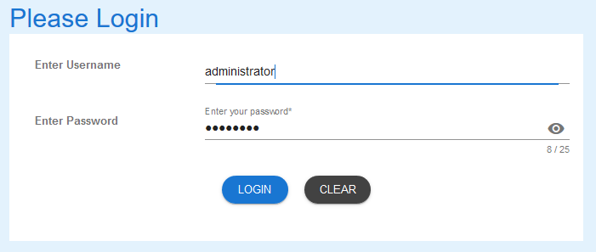

1. Select LOGIN to access PET.

NOTE:

Users entering an invalid username and/or password will not beable to access PET.

## Error Types

User must know what Error Types are to be added to the list.

### Navigate to Manage Error Types

1. From the Welcome Page, there are two ways to navigate to “Manage Error Types”:
   1. Select the “Manage Error Types” from the list



* 1. From the Menu Bar, hover your mouse over “Manage…” and select “Manage Error Types”

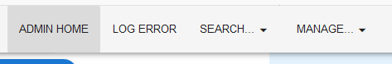

1. The Error Types Details form will appear.

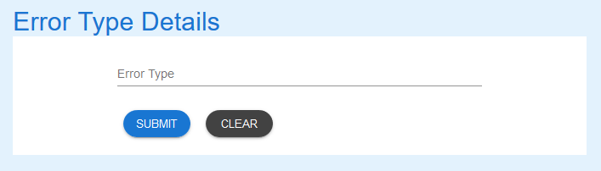

## Create Error Types

User must know what Error Types are to be added to the list.

### Add Error Types

1. To Enter the details of the new Error Type.

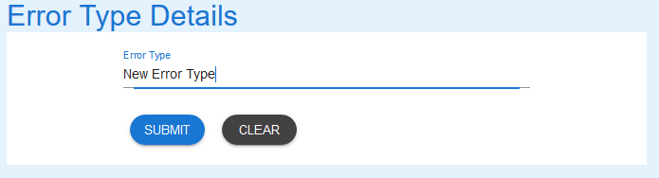

1. Select the SUBMIT button and success message appears.

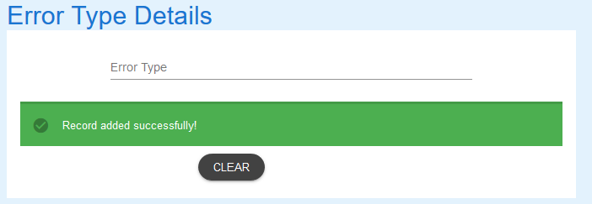

1. Use the Search Error Types User Guide for details to search the database to see record just created.

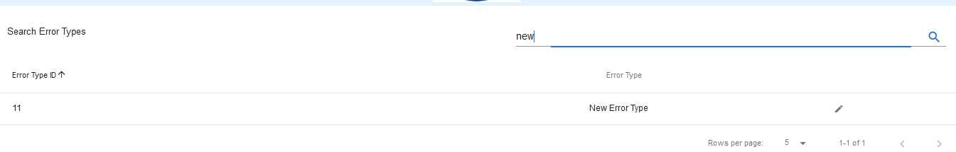

If you encounter issues not addressed by this user guide, please contact your account manager for additional support.